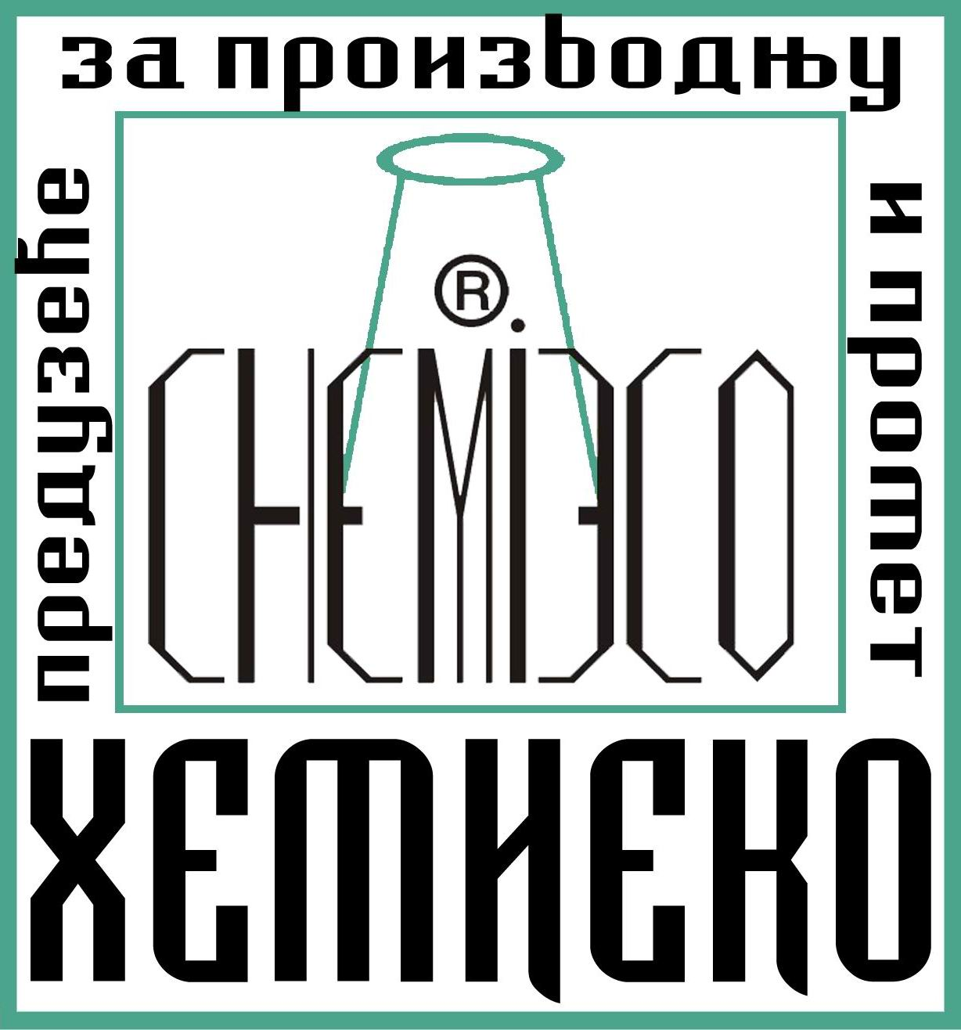

“HEMI ECO” Belgrade 11030
Development & Production center Blagoja Parovića str. 4
Phone 00381 11 3555724
Fax 00381 11 3555724
Mobile 00381 63 318125
00381 62 355511

www.hemieco.co.rs
_______________________________________________________________________________________

PRODUCT PRICE LIST

PRODUCT | PACKAGING | PRICE | Price per unit | In stock | On order
Eco Impregnir K | 1L Plastic bottles | 8,00Eur | 8,00Eur/L | √
Eco Impregnir K | 10L Plastic cans | 70,00Eur | 7,00Eur/L | √
Eco Impregnir MK | 1L Plastic bottles | 14,00Eur | 14,00Eur/L | √
Eco Impregnir MK | 10L Plastic cans | 110,00Eur | 11,00Eur/L | √
Eco Impregnir S | 1L Plastic bottles | 16,00Eur | 16,00Eur/L | √
Eco Impregnir S | 10L Plastic cans | 130,00Eur | 13,00Eur/L | √
Eco Impregnir A | 2x1L Plastic bottles | 52,00Eur | 26,00Eur/L |  | √
Eco Impregnir A | 2x10L Plastic cans | 460,00Eur | 23,00Eur/L |  | √
Eco Impregnir B | 10L Plastic cans | 110,00Eur | 11,00Eur/L | √
Eco Impregnir D | 1L Plastic bottles | 42,00Eur | 42,00Eur/L |  | √
Eco Impregnir D | 10L Plastic cans | 360,00Eur | 36,00Eur/L |  | √
Eco Impregnir M | 2x1L Plastic bottles | 120,00Eur | 60,00Eur/L | √
Eco Impregnir M | 2x10L Plastic cans | 1.100,00Eur | 55,00Eur/L | √
PRODUCT | PACKAGING | PRICE | Price per unit | In stock | On order
Eco Impregnir ME | 1L Plastic bottles | 21,00Eur | 21,00Eur/L | √
Eco Impregnir ME | 10L Plastic cans | 160,00Eur | 16,00Eur/L | √
Eco Impregnir WN | 2x1L Plastic bottles | 140,00Eur | 70,00Eur/L |  | √
Eco Impregnir WN | 2x10L Plastic cans | 1.200,00Eur | 60,00Eur/L |  | √
Silobit | 20Kg Plastic or metal cans | 80,00Eur | 4,00Eur/kg | X | X
Eco Impregnir L | 1L Plastic bottles | 21,00Eur | 21,00Eur/L | √
Eco Impregnir L | 10L Plastic cans | 160,00Eur | 16,00Eur/L | √
Eco IVVO | 2x10L Plastic cans | 320,00Eur | 16,00Eur/L | √
Eco Polymer D | 10L Plastic cans | 130,00Eur | 13,00Eur/L |  | √
Eco Consolid K | 2x1L Plastic bottles | 56,00Eur | 28,00Eur/L | √
Eco Consolid K | 2x10L Plastic cans | 520,00Eur | 26,00Eur/L | √
Eco Consolid M | 1L Plastic bottles | 13,00Eur | 13,00Eur/L | √
Eco Consolid M | 10L Plastic cans | 110,00Eur | 11,00Eur/L | √
Eco Recept 01 | 1L Plastic bottles | 16,00Eur | 16,00Eur/L | √
Eco Recept 01 | 10L Plastic cans | 110,00Eur | 11,00Eur/L | √
Eco Recept 01mod | 1L Plastic bottles | 7,00Eur | 7,00Eur/L | √
Eco Recept 01mod | 10L Plastic cans | 60,00Eur | 6,00Eur/L | √
Eco Recept 02 | 1L Plastic bottles | 16,00Eur | 16,00Eur/L | √
Eco Recept 02 | 10L Plastic cans | 110,00Eur | 11,00Eur/L | √
Eco Recept 02mod | 1L Plastic bottles | 7,00Eur | 7,00Eur/L | √
PRODUCT | PACKAGING | PRICE | Price per unit | In stock | On order
Eco Recept 02mod | 10L Plastic cans | 60,00Eur | 6,00Eur/L | √
Eco Recept 03 | 1L Plastic bottles | 42,00Eur | 42,00Eur/L |  | √
Eco Recept 03 | 10L Plastic cans | 370,00Eur | 37,00Eur/L |  | √
Eco Recept 04 | 1L Plastic bottles | 16,00Eur | 16,00Eur/L | √
Eco Recept 04 | 10L Plastic cans | 110,00Eur | 11,00Eur/L | √
Eco D 01 | 1L Plastic bottles | 16,00Eur | 16,00Eur/L |  | √
Eco D 01 | 10L Plastic cans | 130,00Eur | 13,00Eur/L |  | √
Eco D 02 | 1L Plastic bottles | 16,00Eur | 16,00Eur/L |  | √
Eco D 02 | 10L Plastic cans | 130,00Eur | 13,00Eur/L |  | √
Eco D 03 | 1L Plastic bottles | 16,00Eur | 16,00Eur/L |  | √
Eco D 03 | 10L Plastic cans | 130,00Eur | 13,00Eur/L |  | √

Note: Prices are in EUR.

Belgrade, April 1st, 2024

